3.9 Extension

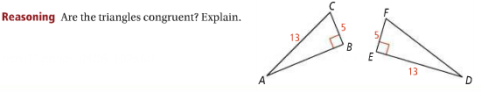

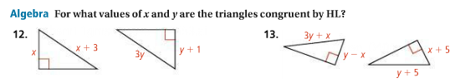

Proof Extension Problem

